# 1.burning programing

Open arduino IDE, because the initial state of arduino does not support ESP8266 development board, and our clock is designed based on NodeMcu, so you can directly install the development board of NodeMcu. The specific process is to enter in the file-preference-setting-accessory development board manager URL:

**http://arduino.esp8266.com/stable/package_esp8266com_index.json.**

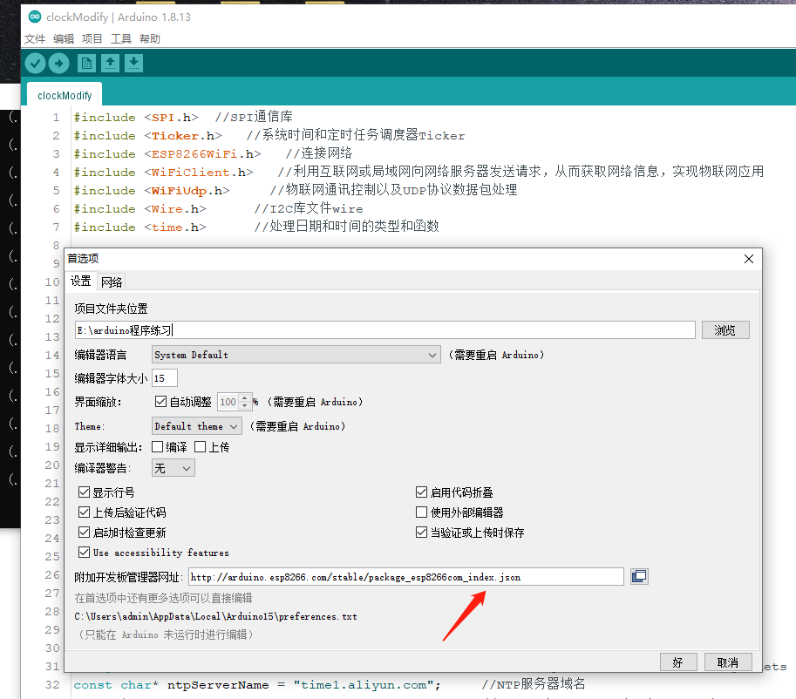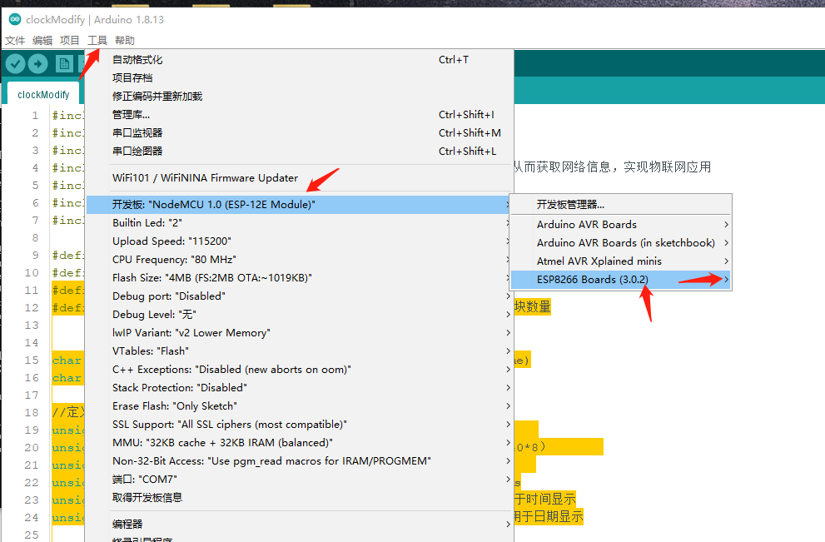

Then go to Tools - Development Board and select NodeMcu 1.0 (ESP-12E Module).

Everything is ready, you can compile it, and install the corresponding library files according to the prompts. In Tools-Port, select the com port where our board is located, then press and hold the Download button on our board, then tap the Reset button, and then release both hands to enter the download mode. At this time, click upload on the IDE, and the download will be completed when the progress bar is finished.

# Configure WIFI

This one has added the automatic network configuration function - SmartConfig. There is no need to write the WiFi account password in the program, you can configure it at will. We need to download a software to realize this automatic network distribution function. If you are an Android mobile phone user, please reply to the official account: "esptouch", you can get the download; if you are an Apple mobile phone user, go to the App Store and search for "Esptouch" to download and install. Take Apple as an example, first connect to the 2.4G Wi-Fi in the environment, then open the software, and enter the Wi-Fi password in the Password field.

 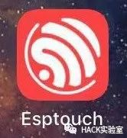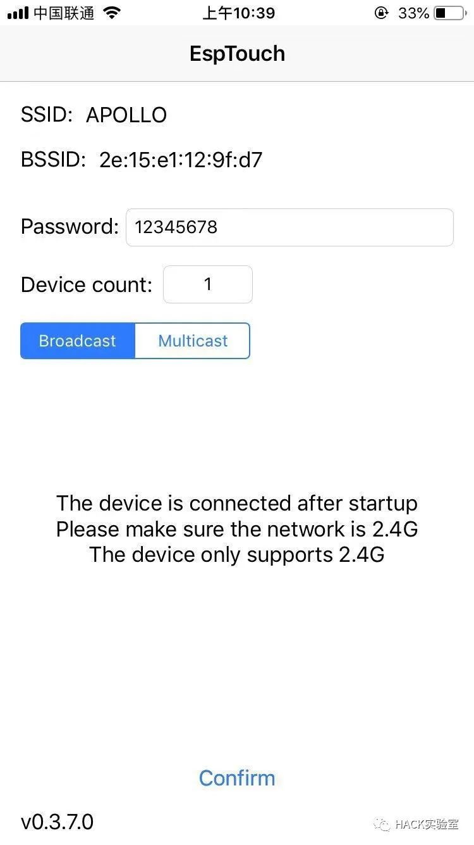

Then power on the matrix clock, the clock displays "Wi-Fi", at this time the clock is the Wi-Fi information set in the connection, the first time it is used because the Wi-Fi information is not set, it flashes "Err! !" indicates that the connection fails and then "S-con" is displayed to enter the network configuration mode. At this time, take out the prepared mobile phone and click "Confirm" to wait. After a few seconds, "OK!!" will be displayed, and the network configuration is successful! After the network is configured, if the router information does not change, there is no need to configure it, and the clock will automatically connect when it is powered on.